**Himachal Pradesh**

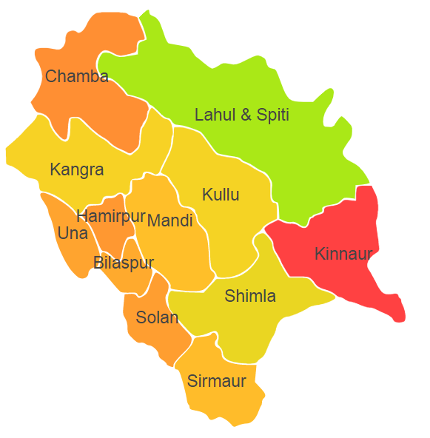

Himachal Pradesh comprises of Agro Ecological Region (AER) 14.

**Agro-Eco Region 14:** AER 14 in Himachal Pradesh comprises of Bilaspur, Chamba, Hamirpur , Kangra, Kinnaur, Kullu , Lahul & Spiti, Mandi, Shimla, Sirmaur, Solan and Una districts of Western Himalayas under Agro Ecological Sub Regions (AESR) 14.1,14.2 and 14.3.

**Major NRM issues :**

**AESR 14.1:** The region is cold and warm by dry semi-arid/dry subhumid ESR with shallow to medium deep loamy Brown Forest and Podzolic soils, low to medium AWC and LGP 90-120 days in a year.

|  |  |  |  |  |
| --- | --- | --- | --- | --- |
| **Districs** | ***Land degradation*** | ***Soil health & fertility*** | ***Water related constraints*** | ***Environmental constraints*** |
| Kinnaur | Water erosion | Soil deficient in N | **-** | **-** |
| Kullu | Exclusively Water erosion | Soil deficient in N | GW Contaminated with NO3 | Extreme Drought |
| Lahul&Spiti | Water erosion | Soil deficient in N | **-** | **-** |

**AESR 14.2 :** The region is warm moist to dry subhumid transitional ESR with medium to deep loamy to clayey Brown Forest and Podzolic soils, medium AWC and LGP 150-210 days in a year.

|  |  |  |  |  |
| --- | --- | --- | --- | --- |
| **Districs** | ***Land degradation*** | ***Soil health & fertility*** | ***Water related constraints*** | ***Environmental constraints*** |
| Bilaspur | Water erosion | - | - | Extreme Drought |
| Chamba | Water erosion, Soil acidity | - | - | Extreme Drought |
| Shimla | Exclusively Water erosion | Soil deficient in B & S | **-** | Extreme Drought |
| Sirmaur | Exclusively Water erosion | Soil deficient in N& S | - | Extreme Drought |
| Solan | Exclusively Water erosion | - | GW Contaminated with NO3 | Extreme Drought |
| Una | Water erosion | Soil deficient in Fe | GW Contaminated with NO3 | **-** |

**AESR 14.3 :** The region is warm humid to perhumid transitional ESR with shallow to medium deep loamy brown forest and podzolic soils, low to medium AWC and LGP 270-300+ days in a year.

|  |  |  |  |  |
| --- | --- | --- | --- | --- |
| **Districs** | ***Land degradation*** | ***Soil health & fertility*** | ***Water related constraints*** | ***Environmental constraints*** |
| Hamirpur | Exclusively Water erosion | Soil deficient in Zn | GW Contaminated with NO3 | **-** |
| Kangra | Exclusively Water erosion | **-** | GW Contaminated with As & NO3 | Extreme Drought |
| Mandi | Exclusively Water erosion | Soil deficient in N | GW Contaminated with NO3 | Extreme Drought |

**Organization and Establishments for Technology Backstopping**

***ICAR Research Institutes:***

|  |  |
| --- | --- |
| Central Potato Research Institute, Shimla | <https://cpri.icar.gov.in> |
| Directorate of Mushroom Research, Solan | <https://dmrsolan.icar.gov.in> |
| KVK Portal | <https://kvk.icar.gov.in/> |

***SAUs/CAUs:***

|  |  |
| --- | --- |
| ChaudharySarwan Kumar Himachal Pradesh Krishi Vishvavidyalaya, Palampur | <https://education.icar.gov.in/Univ_Details_New.aspx?Univ=wrbcK3+wFhwqvjo4aIdpN8PXpb6gYq+z> |
| Dr Yashwant Singh Parmar University of Horticulture and Forestry, Nauni, Solan | <https://education.icar.gov.in/Univ_Details_New.aspx?Univ=yNK/Ak4qZ1cFkADxL4PuIW3GTdEP9kCx> |

***List of KVKs:*** <https://icar.org.in/content/himachal-pradesh#overlay-context=node/129>

***List of Soil testing Laboratories****:* <https://farmer.gov.in/STLDetails.aspx?State=2>